Header …as below
mega menus if possible??

Home page sections:
1. Hero Section
2-3 Rolling Images - and related to AI, Data and Cloud and use text from below options.
Title:
Engineering Intelligence. Delivering Impact.
Subtext:
AI, Data, and Cloud engineered to solve real business problems—securely, scalable, and at speed.

Title:
Transforming Enterprises with Intelligent AI
Subtitle:
Leverage advanced AI, data, and automation to reimagine operations, enhance decisions, and accelerate growth.
Title:
Engineering the Future with AI
Subtitle:
We combine deep engineering expertise with cutting-edge AI to build scalable, production-ready solutions for modern enterprises.
Title:
From Data to Decisions. From AI to Impact.
Subtitle:
Unlock the full value of your data with AI-driven insights, automation, and intelligent systems built for scale.

Title:
Smarter Systems. Faster Outcomes.
Subtitle:
Harness AI and intelligent automation to streamline operations, reduce costs, and unlock new opportunities.

CTAs:
Start a Conversation - standard button under Text in image

Sample design for Hero section
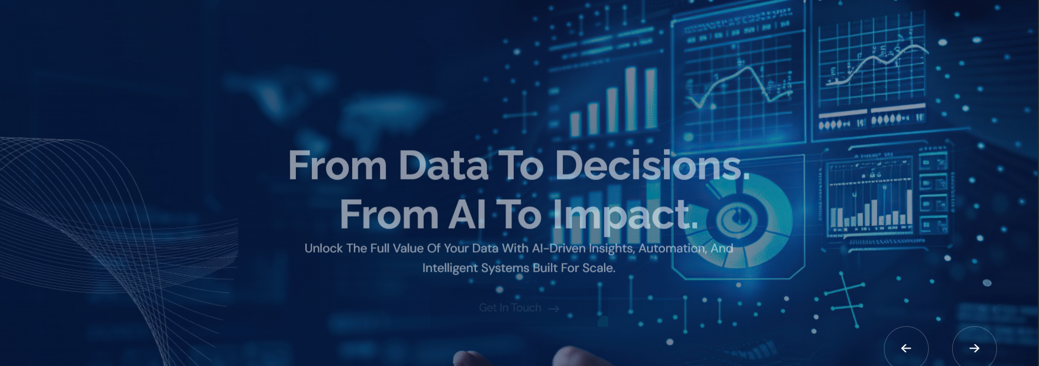

Section - Intelligent Solutions, Engineered with AI
Subtitle: Powering the next generation of enterprises through Generative AI, Agentic Intelligence, and Intelligent Automation delivering speed, intelligence, and scale.

Pl use text from below images but have this section designed
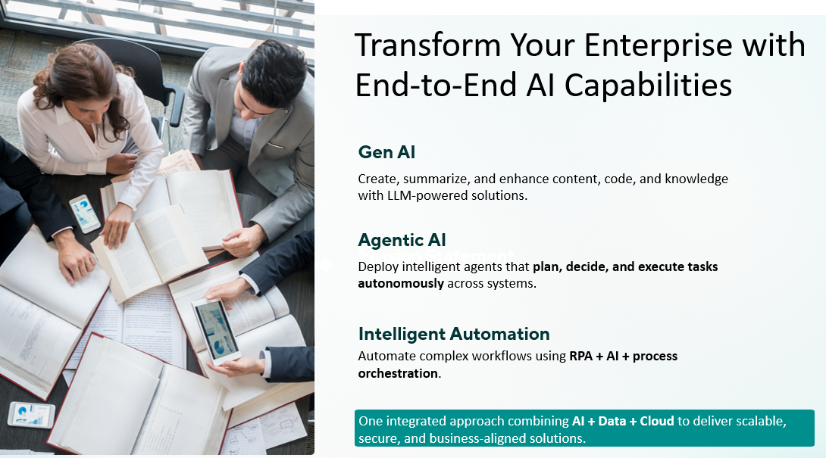

Section - Who We Are
Subtitle:
Built for Complexity. Designed for Scale.
AITVEO combines deep engineering expertise with AI-driven thinking to solve complex, high-impact problems without compromising on security, scalability, or speed.
Vision
To become a global leader in AI-driven enterprise transformation - enabling organizations to evolve intelligently, operate efficiently, and innovate continuously.
Mission
Design and deliver intelligent, scalable, measurable technology solutions that accelerate digital evolution and maximize enterprise value.
Our Core values
Purpose-Driven Innovation.
Execution Excellence - precise, accountable delivery.
Trusted Partnership - integrity and transparency.

Section - What We Do
Subtitle:
Enabling enterprises to transform, scale, and lead through AI, data, and cloud.
<<as per Services in menu>>>

Section - Why Choose AITVEO
Image + Text
1. AI at the Core
At AITVEO, AI is not an add-on - it is foundational. We design solutions where intelligence is embedded into every layer of the system, enabling automation, predictive decision-making, and continuous optimization. This ensures your business operates smarter, faster, and with greater accuracy from day one.
2. Business Outcome Driven
We go beyond technology delivery to focus on what truly matters measurable business impact. Every initiative is aligned with your strategic goals, whether it is increasing revenue, reducing operational costs, or enhancing customer experience. Our approach ensures clear ROI and sustained value creation.
3. Rapid, Agile Execution
Speed is critical in today’s competitive landscape. Our lean, agile delivery model allows us to move quickly from concept to deployment, ensuring faster time-to-value. At the same time, we maintain precision, quality, and scalability in everything we build.
4. End-to-End Accountability
We take complete ownership of your transformation journey from strategy and solution design to implementation and ongoing optimization. This eliminates fragmentation, ensures consistency, and provides you with a single, accountable partner focused on delivering results.
5. Scalable, Future-Ready Solutions
Our solutions are built to evolve with your business. Using cloud-native, modular architectures, we ensure flexibility, scalability, and seamless integration with emerging technologies. This prepares your organization not just for today’s needs, but for future growth and innovation.

Section - Measurable Impact at Scale
Subtitle: Delivering Excellence and Innovation Across Industries Worldwide
quick stats:
100% AI Focused Delivery
15+ Services for Clients
100% Client Satisfaction
30% Faster Delivery Outcomes



Section - Case Studies -- <will enable in 1-2 months>

Section - TESTIMONIALS
Subtitle: Powering Success for Global Enterprises
<<<I will send separate document for the data >>>

Section - Frequently asked questions
1. How can AI create real business value for our organization?
AI delivers value by automating complex processes, enhancing decision-making through predictive insights, and enabling personalized customer experiences. At AITVEO, we focus on outcome-driven AI aligning solutions directly with business KPIs such as cost reduction, revenue growth, and operational efficiency.

2. What is the right approach to starting an AI or data transformation journey?
A successful transformation begins with a clear strategy, strong data foundation, and prioritized use cases. We typically start with an assessment of your current landscape, identify high-impact opportunities, and implement scalable solutions through a phased roadmap ensuring measurable ROI at every stage.

3. How do you ensure data security and compliance in cloud and AI solutions?
We embed security and governance into every layer covering data privacy, access control, encryption, and regulatory compliance. Our solutions are built on trusted cloud platforms like Microsoft Azure, Amazon AWS, and Google Cloud, with industry-aligned best practices for secure and responsible AI.

4. Can AI solutions integrate with our existing enterprise systems?
Yes. Our approach is API-first and cloud-native, enabling seamless integration with existing systems such as ERP, CRM, and legacy platforms. We ensure minimal disruption while enhancing your current ecosystem with intelligent capabilities.

5. How do you measure success and ROI for AI, Data, and Cloud initiatives?
We define success through clear, quantifiable metrics including cost savings, process efficiency, time-to-market, and business growth. Continuous monitoring, optimization, and governance ensure that every solution delivers sustained and scalable value.

Section – sample as Below


Section - Footer as below
Sample below… better design is welcome.
